……….
30723 Sodaville Rd Lebanon, Oregon
August 2017 Volume 8, Issue 17

City Hall (541) 258-8882 Mayor Suzie Hibbert email: sodaville@cityofsodaville.org
Web Address: www.sodaville.org Judy Smith – City Administrator
000000000000…………..000000000000000000000000000000

City Council Meeting City Hall Hours
7:00 pm August 17th, 2017 Mon.–Thurs. 10 am–2 pm
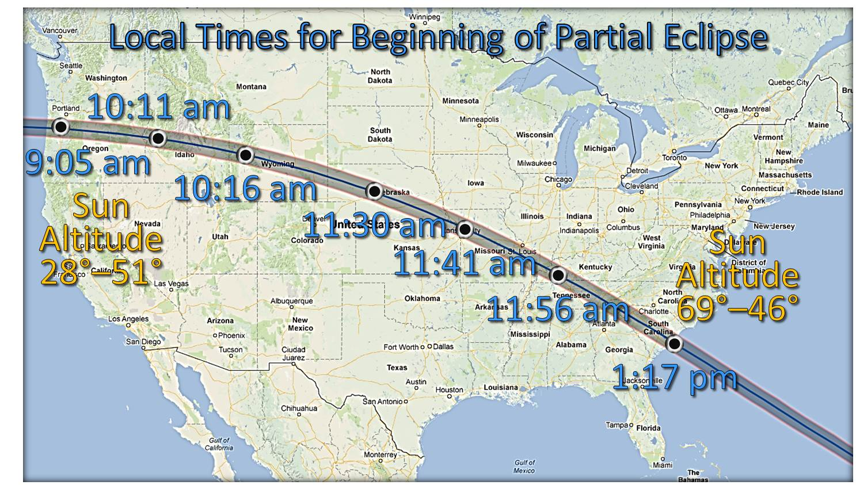
CITY UPDATE
CITY HALL AND PUBLIC WORKS WILL BE CLOSED MONDAY AUGUST 21!!

At the July 20th City Council meeting, Councilor Brian Lewis resigned for personal reasons. If you are interested in becoming a member of the City Council, please contact City Hall. A City Councilor’s duties include: one meeting on the third Thursday of the month at 7:00 pm, serving on the Budget Committee by attending 1 to 2 meetings in May or June, deciding on goals, laws, planning and projects for the City and citizens.

On August 17 at 6:00 pm the City Council will be holding a Workshop with RCAC (Rural Community Assistance Corporation). The proposed Water Rate Study will be presented and discussed at that workshop. Once the details are discussed the study will be presented at a Public Hearing. Details of when the hearing will be held will be on the website and in the September Newsletter.

The addition of a 6th well to the system is taking longer than anticipated between engineering, securing funding including grant monies and governmental paper work. Please be aware that the City’s water system is currently only running on 4 wells. Well #5 is most probably defunct at this point. It has been deepened, cleaned, new equipment, etc., but it is still not producing and has been taken off line. This is the time of year (August thru September) that the aquifer is at its lowest point. Please try to conserve by not using unnecessary water such as washing cars, filling pools, etc. Water Restriction is the last thing the City wants to have to enforce so if everyone works together it may not become a necessity. Besides, not only is it expensive to purchase water from Lebanon, it tastes bad according to the complaints I receive. It is treated with chemicals whereas Sodaville’s water is pure with no chemicals needed.
Judy Smith, City Administrator
MAYOR’S MESSAGE
HOT AUGUST NIGHTS ARE HERE!
It sure has been warm. Water is one of the top things we turn to in order to cool down. Be sure your pets have shade and plenty of drinking water. Bring them inside if at all possible; I've had a LONG week of heat and dogs inside... The other public message. Please be careful with over using water. As Judy states above, our aquifer is getting very low (again) and we'll literally run out of water. Then we'll need to go to Lebanon and buy water. The trucking in water is a huge ordeal and inconvenience for the city, it gets very expensive, along with the bad taste. In the past, Judy has been able to finagle grants to cover those costs, or at least part of them. That is not the case this year. We are working on the grant to buy well #6. As always, working with the State and/or Federal to receive Grants is very time consuming to complete. The 1st meeting with them, they were very optimistic. Since then, it’s been jumping through hoops, upon hoops. Yes, Judy is a pro in hoop jumping. But it takes time. Therefore, the acquisition of well #6 and getting it put online will not be happening this summer as we were first led to believe, although we knew better, just wishful thinking. We are doing our best.
On the note of doing our best, Councilor Brian Lewis has resigned. We are saddened by his decision; he was very good for the city. So, now we are one Councilor short and will need to fill that seat. Interested?? Think it over. Oh, the Citizen's Committee is now leaderless also. The Committee now has very few, if any, members. Therefore, unless several people want to step up and be a part of it, it’s over and done with.

Take care and see you around. Don't be afraid to say hello to your neighbor, it makes living in Sodaville a happier place. Isn't that why we live here?

Suzie Hibbert, Mayor mayorhibbert@gmail.com

Public Works Newsletter

TMDL
In 2007 Oregon’s DEQ (Department of Environmental Quality) started a program called TMDL (Total Maximum Daily Load). The idea behind this program is to reduce pollutants, temperature and turbidity of water carried to streams by storm water. These three items can kill plant life and fish in local streams and ultimately become part of the drinking water system. Pollutants can cause green algae, which lowers oxygen levels in streams. In the City of Sodaville pollutants such as pesticides, bacteria from poorly maintained septic tanks and not cleaning up after your pets can reach Oak Creek and degrade its ecosystem. Temperature and turbidity can affect a streams ecosystem in much the same way as pollutants.

What is the City required to do?
The City of Sodaville is required to monitor storm water for temperature and turbidity in several areas around the City. Another requirement is the removal of invasive plants such as blackberries and ivy on public property. Education is another requirement, which is why you will occasionally see an article in this newsletter about septic issues or cleaning up after your pet. Finally, those excavation permits that are required here in Sodaville are there to reduce turbidity (silt runoff) as well as protect your neighbors.

What about the future of TMDL?
Each year DEQ adds more responsibility to its DMA’s (Designated Management Agencies). Soon we could be testing storm water pretty much the same as drinking water. Testing could include iron, lead, nitrates, nitrites and a host of other contaminants previously only done on drinking water systems. Currently, most cities charge a storm water fee for these services. The City of Sodaville does not charge a storm water fee at this time.

What can you do?
Along with limiting pesticide use, picking up after your pets and maintaining your septic system, become involved! There are several watershed councils in the area that you can join. Look them up. Plant a tree along Oak Creek! Talk to your neighbors along Oak Creek and see if they will allow that first. Shading of waterways is the single most important step in insuring our streams promote the life of fish and other aquatic life. For more information on watershed councils in your area contact me at 541-258-8882.

Stan Smith, Public Works Director
Country Girl Quilting
*Long-arm Machine Quilting

Call Sharon Hill and Joleana Altom at 541-401-7936

Carries Country Inn Adult Foster Home

is located at 30785 Washington Street in Sodaville.
“A safe, comfortable home where you can keep your
dignity, respect and independence.”

For information call: 541-570-1430

If you have any announcements, information or ads you wish to have published in the newsletter, please call before the 6th of the month and I will be happy to insert them!
“The City of Sodaville is an equal opportunity provider and employer.”

