……….
30723 Sodaville Rd Lebanon, Oregon
August 2018 Volume 8, Issue 18

City Hall (541) 258-8882 Mayor Suzie Hibbert email: sodaville@cityofsodaville.org
Web Address: www.sodaville.org Judy Smith – City Administrator
000000000000…………..000000000000000000000000000000

City Council Meeting City Hall Hours
7:00 pm August 16, 2018 Mon.–Thurs. 10 am–2 pm
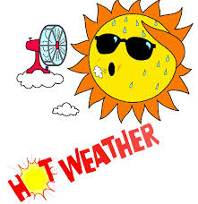
CITY UPDATE

CITY ADMINISTRATOR JUDY SMITH HAD A THROAT TUMOR REMOVED ON MONDAY, AUGUST 6 AND WILL BE UNABLE TO SPEAK FOR 1 WEEK.

FOR questions or concerns during the week of August 6 to August 13, please email City Administrator Judy Smith - Sodaville@cityofsodaville.org or text 541-905-2590. For Water Emergencies call 541-401-8537.
ODF Extreme Fire Danger
- * No Debris Burning
- * Smoking in designated locations, vehicles on improved roads and boats in the water
- * Campfires in designated locations
- * Portable cooking stoves using liquified fuels OK
- * No Fireworks
- * No exploding targets, tracer ammunition or sky lanterns
- * No mowing of dry, cured grass
- * No power saw use
- * No cutting, welding or grinding
- * Electric fences must be UL approved
- * No off-road driving
- * All vehicles must have a shovel and fire extinguisher or gallon of water.
- * ATV's and motorcycles must be equipped with a fire extinguisher
- * Any other spark emitting internal combustion engine not specifically mentioned is prohibited
Water Conservation
It is the time of year when the dry, hot weather starts to affect the wells. Please try to conserve water when possible.

Please remember that ORDINANCE #15-03 NUISANCE also includes Section 15. Water Boxes. It is the responsibility of the customer to keep the water box (meter box) servicing his or her account accessible and free of debris inside and out. A 3 foot diameter clearance from the box is required. If a box is found to be neglected and needs attention, the City of Sodaville and/or the Nuisance Officer, will contact the customer regarding the issue. This may be, but is not limited to, a note on the water billing describing the problems. If within 30 days, the issue is not resolved, and the customer has not contacted the Water Utility or the Nuisance Officer to make arrangements to have the problems corrected the City of Sodaville and/or the Nuisance Officer has the authority to correct such problems and pass the actual costs onto the customer. (A fine can be issued.)
This includes parking on boxes so there is no access to read the meter, placing debris on top of the box and if the lid to the meter box is damaged and has to be replaced, there will be a charge to your account. The City does have the authority to have vehicles towed if they are on top of the water meter box. If your meter can not be read and Stan has to make another trip out to your residence, there will be a charge. It is unbelievable to me the trouble Stan had trying to read meters this month! Meters are read at the first of the month, there should not have been any problems.
Judy Smith, City Administrator
MAYOR’S MESSAGE
August is called the Dog days of Summer and it’s here.

Did you all notice how nice the Park and City Hall looks? Last month, July 22nd 9-12, a dedicated group of people helped spread bark dust and weed eat the hill around the park. It was a warm (hot) day, Stan came in on his day off to run the tractor, My husband and I, Councilor Jeff Hensley, Mike and Linda Baker along with their little girls. Judy brought some delicious Anti Pasta salad for the City BBQ. We had purchased everything for lunch and had no one to share it with. So we went home. It’s very disheartening to not have anyone show up. To help, or at least join us for lunch.

Citizens Committee has meetings 6 pm every 3rd Thursday just before City Council at 7. You are more the welcome to come.

August and September are our driest part of the year. The wells are hanging in there, but any major leak can jeopardize the system. Let’s be on our toes and watch for any wet spots outside the house, driveway or yard. Turn off the fans and air conditioners daily to listen for leaky faucets or running water. We do not want to end up buying water this year. Yes, we are still working on getting the new well and additional holding tank.

Hope to see you around,
Suzie Mayor Suzie Hibbert mayorhibbert@gmail.com

Public Works Newsletter
The hotter and dryer than normal summer weather along with several leaks on water services is starting to take its’ toll on the City's wells. Two of the City's wells are running at reduced levels at this time. The Public Works Department is asking water customers to reduce water use to close to winter levels for the rest of the summer. This is not a water restriction at this time but will help to insure adequate water is available throughout the rest of the summer. The City of Sodaville Public Works Department would like to thank you in advance for your cooperation.

The Public Works Department would like to remind everyone that there are certain rules in place for homeowners regarding your meter box. Please remember to keep your meter boxes accessible at all times. Homeowners are responsible for removing tall grass, blackberry vines and other vegetation from around meter boxes. Never park your vehicles or pile debris on top of meter boxes. Doing so makes finding and accessing the meter in an emergency very difficult. Fines may be issued for violating these rules.

Please do not drive over your meter box. The concrete boxes are made fairly sturdy but driving over them tends to break them. The boxes are fairly old and it's hard to find replacement lids for them.

Stan Smith, Public Works Director
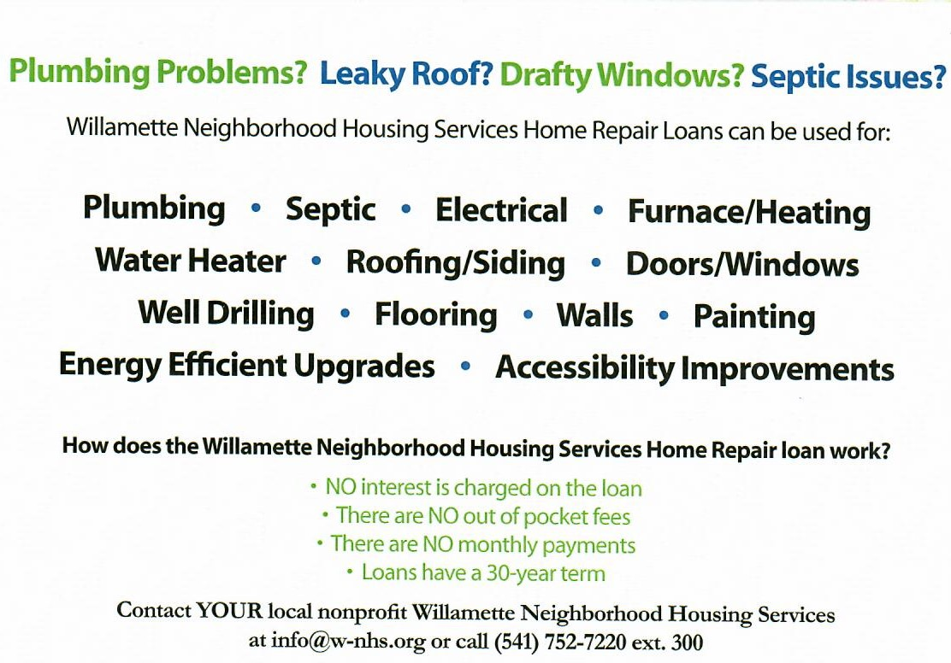
Country Girl Quilting
*Long-arm Machine Quilting
Call Sharon Hill and Joleana Altom at 541-401-7936
Carries Country Inn Adult Foster Home
is located at 30785 Washington Street in Sodaville.
“A safe, comfortable home where you can keep your
dignity, respect and independence.”
For information call: 541-570-1430

If you have any announcements, information or ads you wish to have published in the newsletter, please call before the 6th of the month and I will be happy to insert them!
“The City of Sodaville is an equal opportunity provider and employer.”

