……….
30723 Sodaville Rd Lebanon, Oregon
March 2019 Volume 3, Issue 19

City Hall (541) 258-8882 Mayor Suzie Hibbert email: sodaville@cityofsodaville.org
Web Address: www.sodaville.org Judy Smith – City Administrator
000000000000…………..000000000000000000000000000000

City Council Meeting City Hall Hours
7:00 pm March 21, 2019 Mon.–Thurs. 10 am–2 pm
CITY UPDATE

city hall and public works will be closed MARCH 25 - 29
The City of Sodaville Budget Committee is looking for members. I will begin working on the 2019-2020 Fiscal Year Budget over the next month. It is the Budget Committee’s job to review the Budget I propose and make a recommendation to the City Council. There will be one meeting at the end of May and if needed, one meeting at the beginning of June. The Budget has to be passed by June 30 by the City Council. If you are interested in serving on the committee, please contact City Hall!!

City of Sodaville History:
Hotel Fires
One night in May 1893, a fire stated in the Hardman hotel on the northwest corner of the block. It spread to a 64 by 64 hall in the center of the block and then to the 23-year-old Carmichael hotel on the south corner. By the time the fire was out, much of Sodaville had burned.

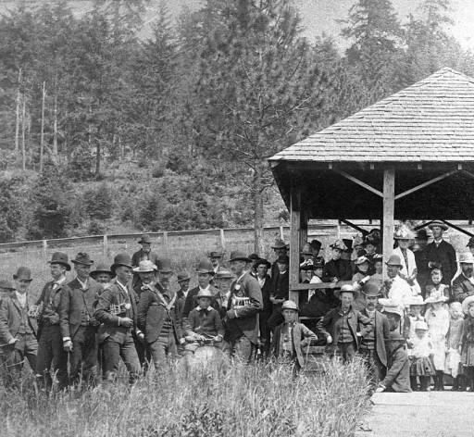
J.P. Chesshire built another hotel on the southwest corner and the band built its hall in 1896 on the site of the old hall.

When that hotel burned in 1907 the band hall was saved only by the most
strenuous of efforts. Fire took the hall, however, in 1929. (Band Concert 1880 Pic)

Judy Smith, City Administrator
MAYOR’S MESSAGE
Woo hoo! It’s March and the Lion is a roaring from the cold. Be safe and stay cozy.

Budget Committee Members are needed. The meeting schedule will be decided by you. Meetings will be done in May or June. Should be just 2 meetings and we will have food.

At 6:30 on March 21 is the Citizen Planning Committee meeting. We will start putting our float ideas together Strawberry Parade. This year’s theme is Adventure. Let’s make this a fun time, join us!

7.00 March 21 is the Council meeting, if you have something other than a comment to address to council, contact Judy and let her know, we will put you on the agenda. Thank you.

Take care,

Suzie mayorhibbert@gmail.com

Public Works Newsletter
In last month’s article I mentioned the lack of rainfall for this year. Well I think we just made up for it!

With the recent snow and rain I feel the rainfall for the year is enough to take us into the Summer months. Static level tests on the City's wells are scheduled for this month and will tell us more about the aquifer levels that feed the City's wells. Conservation is the key to making it through the Summer months.

On March 13th the City will have divers coming in to clean the City's reservoir. The City maintains the reservoir on an every five year basis. The divers clean debris from the floor of the reservoir and look for any signs of corrosion on the metal tank. If needed, they recommend certain items be repaired while they are in the tank. It is important to note that this method of cleaning does not interrupt the flow of water to your tap.

Have a great Spring.

Stan Smith, Public Works Director

Country Girl Quilting
*Long-arm Machine Quilting
Call Sharon Hill and Joleana Altom at 541-401-7936

Carries Country Inn Adult Foster Home
is located at 30785 Washington Street in Sodaville.
“A safe, comfortable home where you can keep yourdignity, respect and independence.”
For information call: 541-570-1430

If you have any announcements, information or ads you wish to have published in the newsletter,
please call before the 6th of the month and I will be happy to insert them!

“The City of Sodaville is an equal opportunity provider and employer.”

