……….
30723 Sodaville Rd Lebanon, Oregon
April 2019 Volume 4, Issue 19

City Hall (541) 258-8882 Mayor Suzie Hibbert email: sodaville@cityofsodaville.org
Web Address: www.sodaville.org Judy Smith – City Administrator
000000000000…………..000000000000000000000000000000

City Council Meeting City Hall Hours
7:00 pm April 18, 2019 Mon.–Thurs. 10 am–2 pm
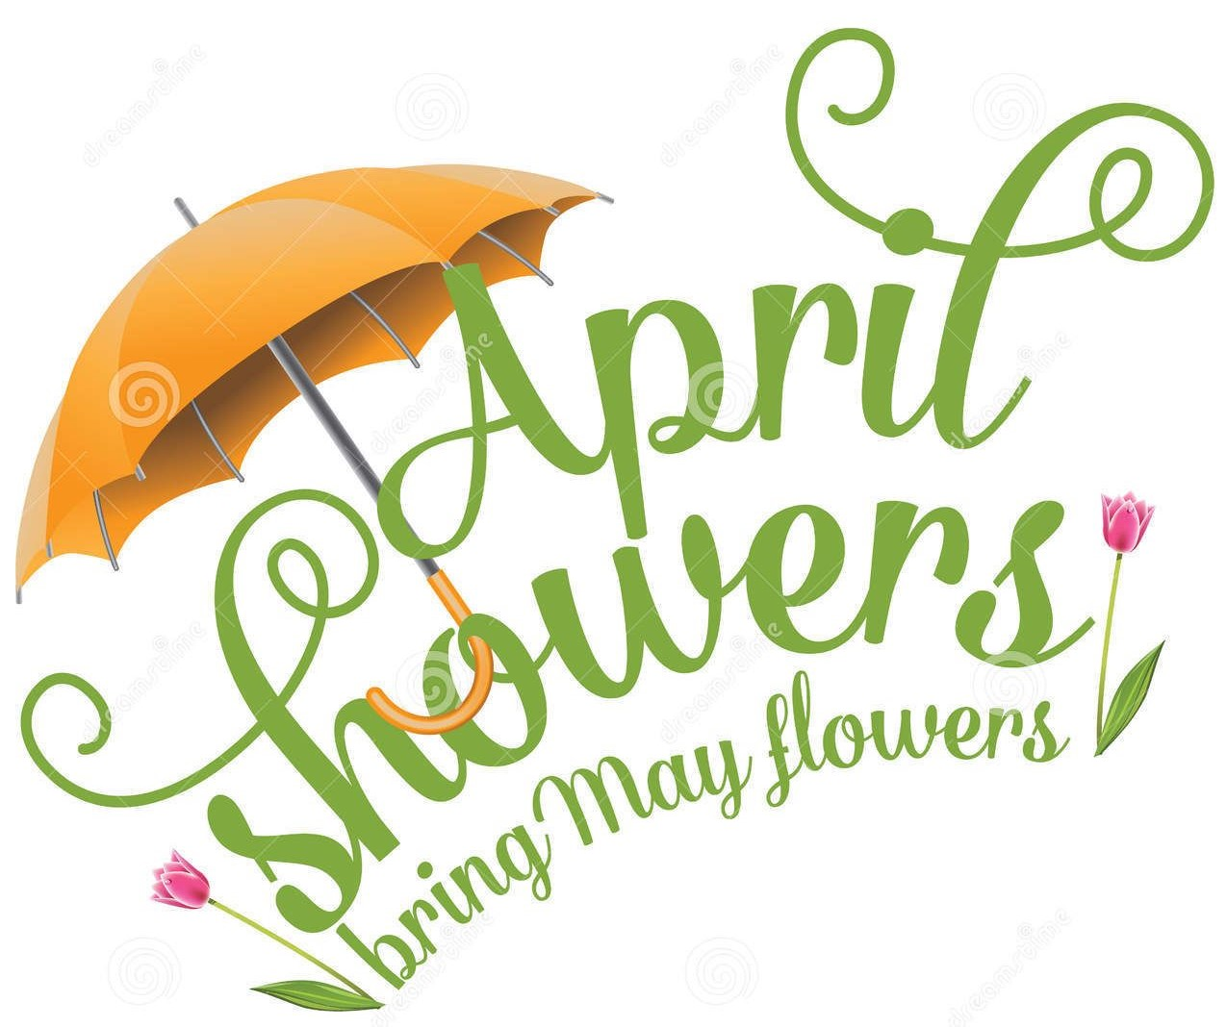
CITY UPDATE

city hall and public works will be closed APRIL 22, 2019
The City is asking for very important information from citizens! If you have had an accident or near accident at the intersection of Cascade Drive and Sodaville Road, please let the City know. A letter was sent to the County Road Department about the major concerns regarding this intersection back in December 2015, with no response. Since the letter, Council President Roger Perry’s wife Kelly became a victim of a major accident there on March 8, 2019 and passed away along with numerous other accidents and near accidents. The City Council is gathering information to present to the County to inform them that something urgently needs to be done to make the intersection safer. This information can be sent in with your water payment, or if you use bill pay, please email sodaville@cityofsodaville.org! Thank You!!
As you may have noticed there has been a lot of activity in the Soda Springs Community Center Park. Big Valley Builders has been hard at work installing a septic, building the parking lot (which will have asphalt), the BBQ patio and sidewalk, and is now working on the restroom that will have running water and electric. The playground equipment has been ordered. It is so very important that volunteers help to build the structure. The City has to provide matching funds in the way of volunteers, services, donations, etc. for the $225,000 grant from the Oregon Parks and Recreation Department. Watch the website for exact dates and times to help.
The City of Sodaville Budget Committee is looking for members. I have begun working on the 2019-2020 Fiscal Year Budget. It is the Budget Committee’s job to review the Budget I propose and make a recommendation to the City Council. Budget Members will be sworn in at the April 18 City Council Meeting taking place at 7:00 pm. There will be one meeting at the end of May and if needed, one meeting at the beginning of June. The Budget has to be passed by the City Council before June 30. If you are interested in serving on the committee, please contact City Hall or attend the City Council meeting (meeting starts at 7:00 but swearing in of members 7:30)!!
City of Sodaville History:
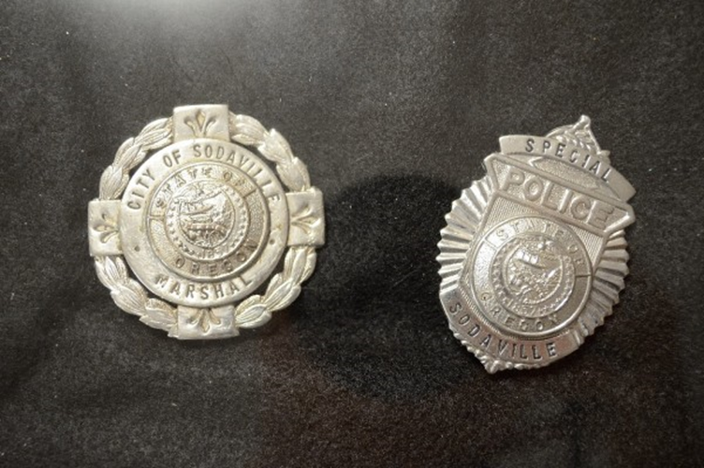
By about 1910 the town had become so peaceful and sleepy that a blind man, George Price, was elected City Marshal and served with distinction.
(The badges were stolen
from City Hall in October, 2014)

Judy Smith, City Administrator
MAYOR’S MESSAGE
Whoa! Look at it rain! April showers are pouring buckets! As we drove around the flat lands looking at all the flooded fields, creeks, rivers and ditches, overflowing the roads. Sodaville does not have those issues to that effect whatsoever. Yes, we have a few overflows/floodings, no extensive damage.
The park is coming right along. Playground Equipment is coming soon! Our contribution is necessary for the grant. It’s OUR job to put the Playground equipment together. Those donation hours counts as monetary payment towards the grant. Come to the Citizens Planning Committee meeting on April 18th @6:30 pm. We will be setting dates for a few huge work parties to get it assembled and you are requested to be at the work party. Please, I cannot stress enough that we need your help. There will be plenty of things for everyone to do.
The Parade Float is in the works, come be a part of the fun. We hope to be planning the float and making up the list of necessary materials to get it put together. Please watch for dates on our website and we’ll post them on the info kiosk in the park.
Budget Committee is this month, April 18th @7pm, council meeting to be sworn in and set dates for the Budget Meetings. We need a few more people to join us. I invite you to come be a part of, or watch the process, see how we are spending the money. And why we say we need more.
The City is still working on the new well. We have continued to hit snags but we are continuing to strive on making the best decisions for Sodaville.
Judy does a wonderful job updating the City’s website. All dates, meetings, work parties, etc. are updated frequently. www.sodaville.org
Take care,
Suzie mayorhibbert@gmail.com

Public Works Newsletter
March has been an extremely busy month for me. Most of the reports required by the State of Oregon are due in March. Linn County came out on behalf of the State of Oregon for a Sanitary Survey of the City's water system. The Sanitary Survey is done every three to five years depending on their findings. The last Sanitary Survey was done in 2014 and resulted in an “Outstanding Performer” status for the water system. Testing for arsenic has been extended from every three years to every nine years as a result of this year’s survey.
Each year in March the City of Sodaville checks the static level of its wells. The results are in and right now it doesn't look good. The City's top producing wells are down much lower than previous years. However, if the City experiences heavy Spring rains aquifer levels could come up to near normal.
The City's water reservoir got a clean start in March. Divers from Liquivision Technology a company based in Klamath Falls Oregon came in and cleaned the water reservoir and assessed any repairs needed. No repairs were recommended at this time. On a scale of 1 to 10 with 10 being the best they gave the City's water reservoir a 7.
Stan Smith, Public Works Director
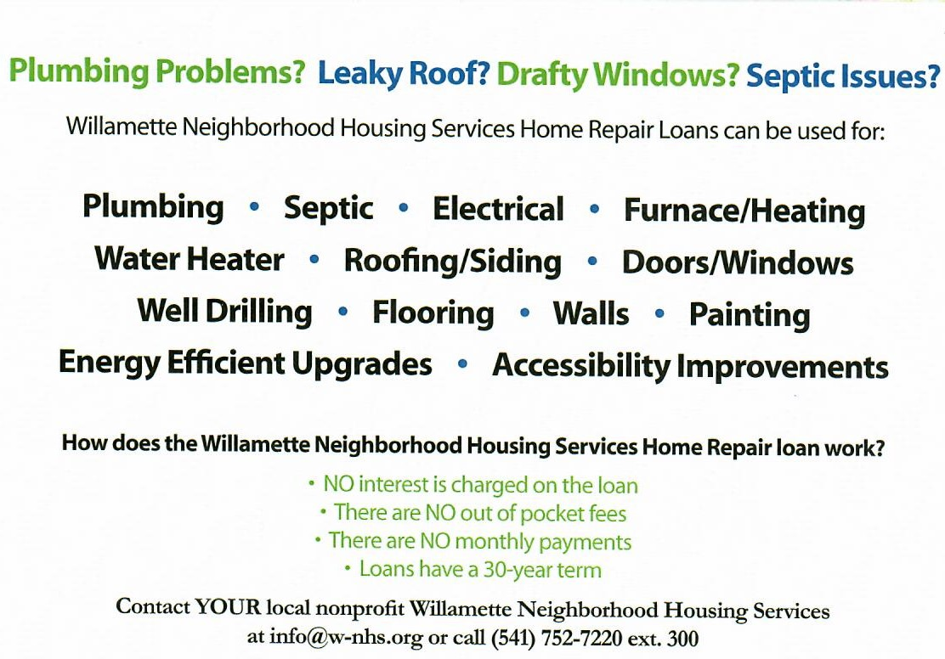

Country Girl Quilting
*Long-arm Machine Quilting
Call Sharon Hill and Joleana Altom at 541-401-7936

Carries Country Inn Adult Foster Home
is located at 30785 Washington Street in Sodaville. “A safe, comfortable home
where you can keep your dignity, respect and independence.”
For information call: 541-570-1430

If you have any announcements, information or ads you wish to have published in the newsletter,
please call before the 6th of the month and I will be happy to insert them!

“The City of Sodaville is an equal opportunity provider and employer.”

