……….
30723 Sodaville Rd Lebanon, Oregon
May 2019 Volume 5, Issue 19

City Hall (541) 258-8882 Mayor Suzie Hibbert email: sodaville@cityofsodaville.org
Web Address: www.sodaville.org Judy Smith – City Administrator
000000000000…………..000000000000000000000000000000

City Council Meeting City Hall Hours
7:00 pm May 16, 2019 Mon.–Thurs. 10 am–2 pm

CITY UPDATE

city hall and public works will be closed MAY 27, 2019
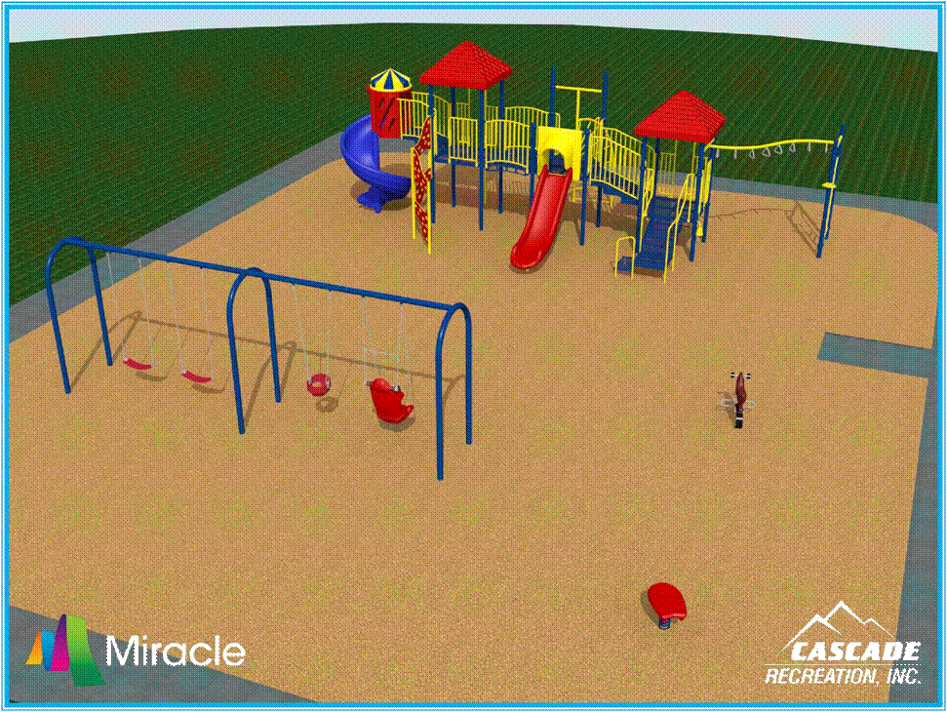
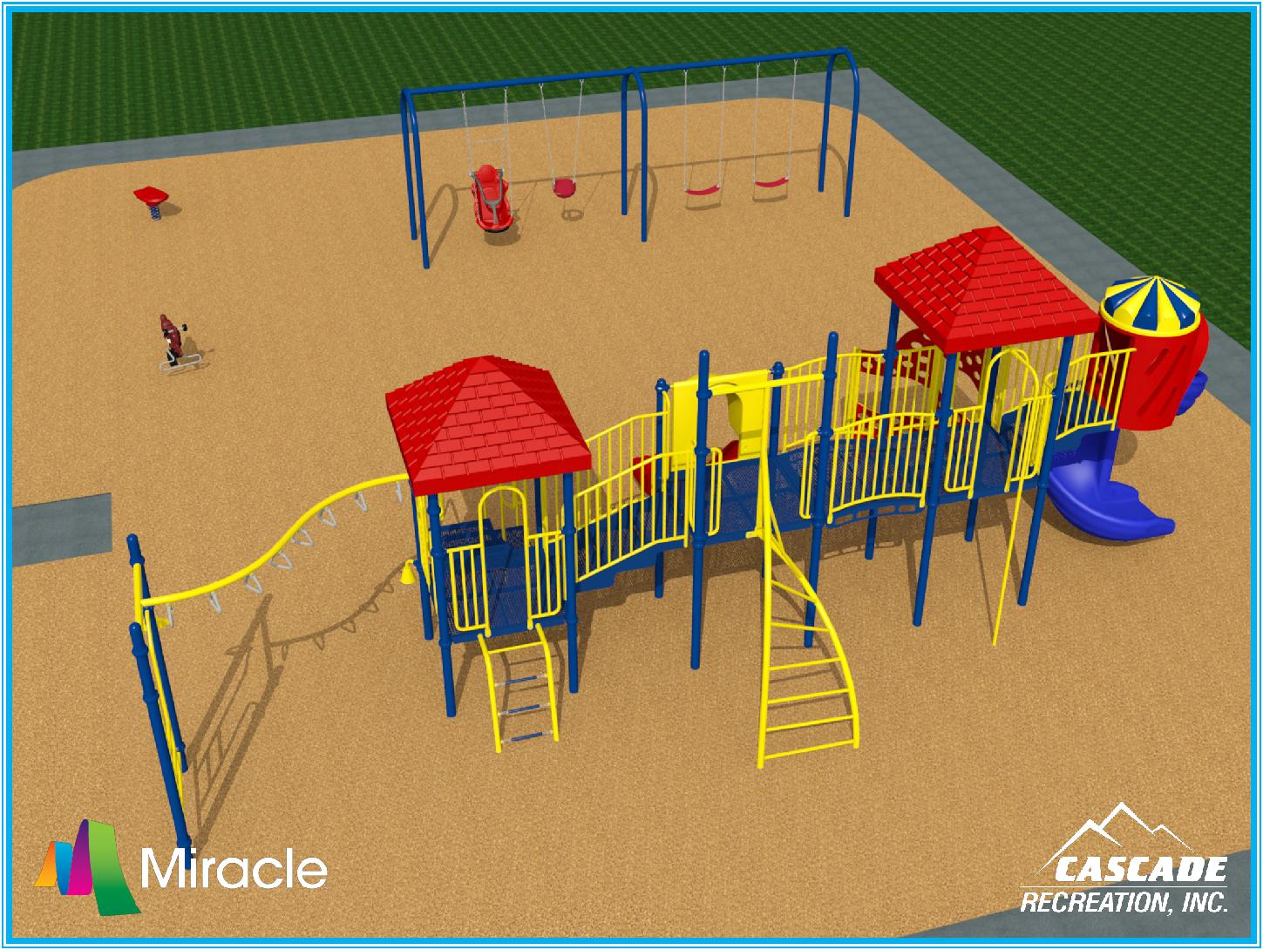
VOLUNTEERS ARE NEEDED TO HELP BUILD
THE NEW PLAYGROUND EQUIPMENT AT THE
SODA SPRINGS COMMUNITY CENTER PARK ON
MAY 18 & MAY 19 FROM 8:00 AM TO 4 PM.
FOOD & DRINK WILL BE PROVIDED

Thank you to Peggy Bishop, Lori McAllen and Scott Logan for volunteering to serve on the Budget Committee. If you are also interested, attend the Council Meeting, May 16 or the Budget Committee meeting, May 23 at 6:00 pm.

There are 2 Public Hearings scheduled for the May 23rd Special Session Council Meeting. Meeting starts at 7:00 pm.
- To consider a Zoning Amendment for 13S 01W 0600 422 from Public Zone to Residential Zone
- To consider a Code Amendment for Accessory Use Dwellings

City of Sodaville History: Indian Cemetery
The claims of William Klum and his son George W. Klum were over the hill, east of the spring. George Klum was an early office holder, serving on the board of the first election held in Lebanon in 1848. Henry Klum, younger half-brother of George, and a veteran of the Indian wars, who died in Lebanon, told of the Indians who were numerous in the early days. There was an Indian burial place on his father’s claim. He recalled hearing the wailing and mourning of the approaching burial trains when they were still miles away. The Klums respected this cemetery, never disturbing the articles placed on the graves, -- beads by the bucketful, dishes, arrows and guns. In later years, Henry and his nephew, Hiram Klum, each tried to find the location of these graves, but could not. Changes in trails, roads and fences and growth of underbrush and timber had completely obliterated old landmarks.
Judy Smith, City Administrator
MAYOR’S MESSAGE
Hey there! MAY a very busy month and yet, we need your help. Our Playground equipment has arrived!! Let’s everyone come together and set this up! Give the kids in town somewhere to play. We are very excited for all the improvements we are getting done for this City and that means getting done for YOU and your family. Playground set up is May 18th/19th from 8 am - 4 pm. Gather your family, friends and neighbors, Coworkers and whoever else you can think of and come help us knock it out! It’ll be fun to build this together.

Budget Committee is May 23rd @ 6pm and June 5th @ 7pm (if needed). We need 3 or more volunteers. If you think someone else will do it, you are wrong. You need to do it, see you there.

As you are aware, the dangerous intersection at Cascade Dr. and Sodaville Rd. has claimed a life. How many of you have had close calls? How often has it occurred? We, the City Council members have reached out to Linn County on several occasions to no avail. On May 21, @ 9:30 (SEE www.sodaville.org to confirm time/place) we will be going to the Linn County Commissioners to be heard. If you are available to join us, please do so, something must be done. So many of our family members have come to a screeching halt to avoid being hit. The County is aware of the problem. Let’s get some action to make it a safer intersection for us all.

See you all soon!

May 18/19 @ the Soda Springs Park Playground
May 21 @ Linn County Commissioner’s Office Intersection Safety
May 23 @ City Hall Budget Committee

Suzie mayorhibbert@gmail.com

Public Works Newsletter
As announced in last month’s newsletter the City recently had a sanitary survey done by Linn County Health on the water system. I am happy to announce that no significant deficiencies were found and the water system achieved “Outstanding Performer” for the second time in its history! As a result the City remains on a five year schedule for the survey instead of a three year schedule. Also, testing for arsenic in the water has shown a non-detect for several years and as a result testing has been extended from every three years to every nine years.

The City's leak rate has jumped up! If you see water coming from an area where there should not be and it is near a water line please call the City's emergency phone number to report it. The number is 541-401-8537. I will check it out and determine if it is a leak or a seasonal spring.

The City's Soda Springs Park Project is coming together. The new public restroom will be finished soon. The parks playground has arrived and the area where the playground will go has been excavated to grade. The City is asking for volunteers to show up on May 18th and 19th to help install the playground. There is a barbecue planned for the volunteers as well. For more information please call City Hall at 541-258-8882.

The City now has a signed contract with ODOT for the paving of Washington Street. The Small City Allotment Grant is for $100,000 dollars. Washington Street will be widened in places and paved its entire length from Main Street to Cottage Street. The City hopes to have this project completed by the end of the summer.

Stan Smith, Public Works Director

Country Girl Quilting
*Long-arm Machine Quilting
Call Sharon Hill and Joleana Altom at 541-401-7936

Carries Country Inn Adult Foster Home
is located at 30785 Washington Street in Sodaville. “A safe, comfortable home
where you can keep your dignity, respect and independence.”
For information call: 541-570-1430

If you have any announcements, information or ads you wish to have published in the newsletter,
please call before the 6th of the month and I will be happy to insert them!

“The City of Sodaville is an equal opportunity provider and employer.”

